NEHRU SCIENCE CENTRE, MUMBAI
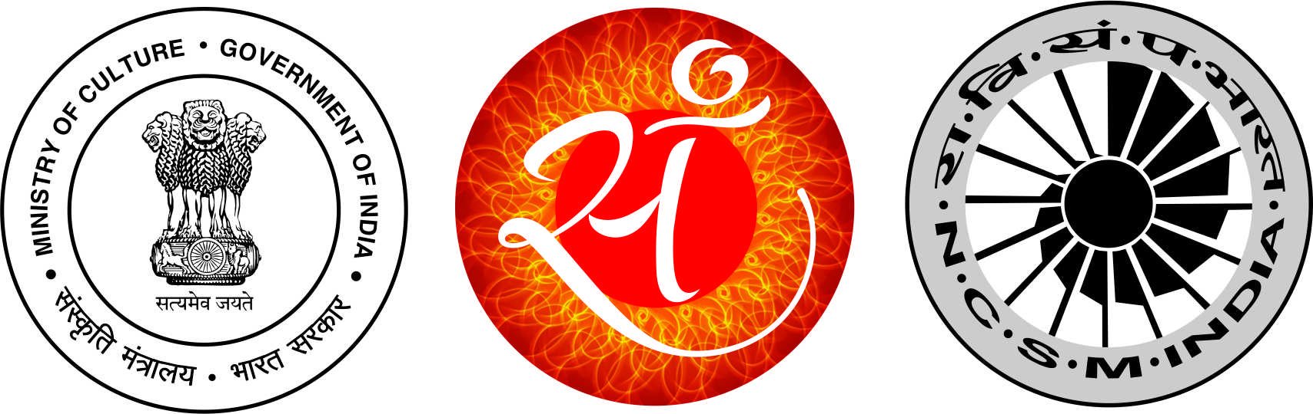

INNOVATION FESTIVAL 2016
(29 – 31, January 2016)

REGISTRATION FORM

- Name & Address of the school/college : _________________________________________________________

- Name of the contact person : _____________________________ Phone: _____________________

To, The Director
Nehru Science Centre, Mumbai
Sir,
We are interested to send the following number of students for various programmes, lectures, contests and workshops, which are being organized during Innovation Festival 2016 at the Centre.

Sr.  No. | Programme / Contest | Date & Time | Particulars
1. | Exhibition by Innovators | 29th – 31st January 2016  (11.00 AM to 8.00 PM) | Date of Visit:_______________  No. of Students:________________
2. | Innovative Project Competition for school students | 29th – 31st January 2016  (11.00 AM to 8.00 PM) | Date of Visit:_______________  No. of Students:________________
3. | Popular Science Lecture by  Prof Anil Gupta, Indian Institute of Management, Ahmedabad  Topic: Grassroot Innovations in India | 30th January 2016  (11.00 AM to 12.30 PM) | No. of Students:________________
4. | Science Film Shows  Topic: Science and Innovations | 29th January 2016  (1.00 PM – 1.45 PM) | No. of Students: ________________
 |  | 30th January 2016  (10.00 AM to 10.45 AM  &  1.00 PM to 1.45 PM) | No. of Students: ________________
 |  |  | No. of Students: ________________
 |  | 31st January 2016  (10.00 AM to 10.45 AM  &  1.00 PM to 1.45 PM) | No. of Students: ________________
 |  |  | No. of Students: ________________
5. | Painting Contest  Topic: My Innovative Idea/s for Smart City | 31st January 2016  (11.00 AM to 1.00 PM) | No. of Students: ________________
- Workshops in association with Paramparik Karigar
1 | Palm Leaf Etching  By Das Narayan, Puri, Orissa | 29th January 2016  (12.00 Noon – 2.30 PM) | No. of Students/ teachers: _____________
2 | Sanjhi Art  By Soni Vijay, Mathura, U P | 29th January 2016  (3.30 PM – 6.00 PM) | No. of Students/ teachers: _____________
3 | Dabbu Printing  By Chippa Bherulal , Rajasthan | 30th January 2016  (11.00 AM to 1.30 PM) | No. of Students/ teachers: _____________
4 | Patachitra – Scroll Painting  By Khandu Chitrakar, West Bengal | 30th January 2016  (2.30 PM – 5.00 PM) | No. of Students/ teachers: _____________
5 | Pipli Applique Art  By Parida Bharat Bhushan, Puri, Orissa | 31st January 2016  (11.00 AM to 1.30 PM) | No. of Students/ teachers: _____________
6 | Bandhni art  By Khatri Naushad Jakariya, Kutch, Gujarat | 31st January 2016  (2.30 PM – 5.00 PM) | No. of Students/ teachers: _____________
- Workshop in association with National Institute of Fashion Technology
Tricky Photography  By Shri Prabhakar, NIFT, Mumbai |  | 30th January 2016  (11.00 AM to 12.30 PM) | No. of Students: ________________

Date Signature of the Principal

