NATIONAL AEROMODELLING COMPETITION AT AMRELI, GUJARAT
UNDER THE AEGIS OF AERO CLUB OF INDIA

INTRODUCTION

1. Aero Club of India (ACI) is organizing National Aeromodelling Competition at Amreli, Gujarat from 19 Feb 2016 to 21 Feb 2016. Gujarat government has promised full support in this endeavor and based upon the past successes and experience in organizing Aero-modeling competitions, Aero-modelers Association of India (AMAI) http://www.amai.in/ has been entrusted with the responsibility for conducting and making this event a grand success.

2. Aero Club of India (ACI) http://aeroclubofindia.in/is National Aero sport Controller (NAC) in India for Federation Aéronautique Internationale (FAI) http://www.fai.org, the World Air Sports Federation, the only world governing body for air sports, aeronautics and astronautics world records. Its head office is in Lausanne, Switzerland.

ABOUT AMRELI CITY

`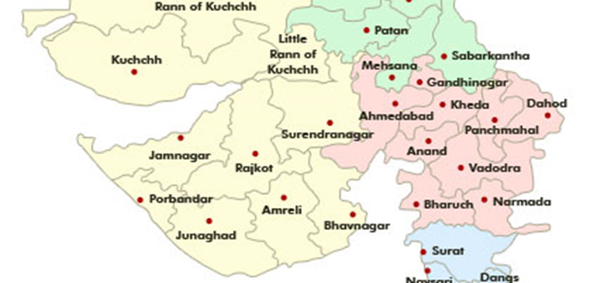
AMRELI

3. Amreli District is named after the city name Amreli, which is the main District head quarter. Amreli District was formerly a part of Vadodra District and ample of informations are available. From the holy stone of Shilalekh of Holy Temple Nagnath at Amreli it has came to be known that Amreli was known as Amravaali in historical age. See more at: http://collectoramreli.gujarat.gov.in

AMRELI AIRPORT

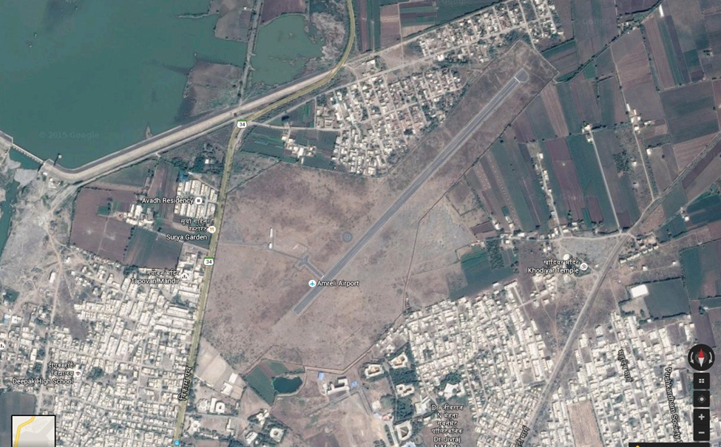

RUNWAY – AMRELI AIRPORT

Amreli Is a small town in southern Gujarat (21.4167° N, 70.7500° E), has a small airstrip, Bhavnagar to the E, Junagadh to the W and Diu/ Somnath to its SW.

Statistics - Runway
Length : 1260 Meters Approx | Width : 30 Meters Approx
Elevation : 439 AMSL | Orientation : 04 – 22
Slope : N/A | Average Wind Speed : 10 Mph Avg.
Temp Day Feb: 18– 28 C | Co-ordinates : Latitude: 21°37'095"N, Longitude: 71°13'379"E

REGISTRATION

Registration Fees: All flyers – Any Category
Sr. No. | Flyers Category | (19 - 22 Jan 2016)
1 | All Flyers of Jets and Props and Helis  (Above 15 years of age) | Rs.1500 Rs
2 | All Flyers below 15 years of age. | Rs.1000 Rs

Registration Fees: Visitors / Non Flyers
Sr. No. | Visitors / Non Flyers | (19 - 22 Jan 2016)
1 | All visitors above 15 yrs of age | Nil
2 | Junior (2-15 years age) | Nil
3 | Less than 2 years (Subject to special permission – child should compulsorily be accompanied by visiting adult guardian) | Nil  Nil
4 | Attendants / Driver accompanying the flyer  (restricted to 1 each per flyer) | Nil
5 | Per vehicle of Flyers / Visitors | Nil

SALIENT POINTS – REGISTRATION

4. The following points must be adhered to :-

(a) All payments at the Registration counter- cash only.

(b) Fees shall be charged Date specific as given above.

(c) Registration for flyers Will Close at 1400 Hrs, on 20th Feb 2016.

(d) Entry will be subject to registration by all participants / visitors at the registration counter.

(e) Vehicles and drivers of flyers will be given an entry pass for parking in the allocated zone close to the visitor's area.

(f) Drivers and attendants of visitors should not enter the flying field unless registered as Visitors.

(g) All associate members of ACI, as on date, on proof thereof, will be eligible to a 0% discount on the registration fees only.
(h) All the above discounts, as may be applicable, will be extended concurrently and not severally. No further concessions would be admitted on account of any other charges, including for assistants and guests. Past members whose membership may have expired or defaulting members will not be eligible to any discounts.

(j) Sponsors and such other associates may be extended complimentary facilities as per the policy of the organizers.

(k) Service Staff/Vehicles & such other collaterals, as may be deemed fit, will be provided free access to the flying field, by the organizers.

SCHEDULE OF EVENTS

NOTE - THE SCHEDULE WILL BE REVISED AS PER THE NUMBER OF PARTICIPANTS IN AS MANY CATEGORIES, AFTER REGISTRATION OF PARTICIPANTS.

FRIDAY, 19 FEB 2016
0800 ONWARDS | REGISTRATION STARTS | At flying Strip
0830 -0900 | Skydiving / Hot Air ballooning | Demo by Armed Forces team.
0900 -0930 | Foot Launched Hang Gliding | Demo by Armed Forces team..
0930 -1000 | WELCOMING SESSION | By ACI
1000 -1100 | FREE FLYING | All Type
1100 -1200 | F3A & F5A Round 1 | Aerobatic Aircraft (include Electric)
1200 -1230 | NOVICE-FREE-FLYING | Glow & electric Aircraft Only
1230 -1330 | F3M-Round 1 | Large Aerobatic Aircraft
1330 -1400 | NOVICE-FREE-FLYING | Gas & electric Aircraft Only
1400 -1500 | F3S & F4C & F4K Round-1/Final | Jet, scale model aircraft & Helicopter
1500 -1530 | NOVICE-FREE-FLYING | All type
1530 -1630 | F3C & F3N Round-1 | R/c aerobatic Helicopter
1630 -1730 | Powered Parachute joyrides | As per instructor availability
1730 -1830 | FREE FLYING | All Type

SATURDAY, 20 FEB 2016
0800 -0900 | FUNFLYING | All Types
0900 -1000 | F3A & F5A Final | Aerobatic Aircraft (include Electric)
1000 -1030 | Model Rocketry | Global air sports Team
1030 -1200 | F3M-Final | Large Aerobatic Aircraft
1200 -1300 | Model Rocketry | Global air sports Team
1300 -1400 | F3C & F3N Final | R/c aerobatic Helicopter
1400 -1500 | FREE FLYING | Helicopter only
1500 -1600 | F3D & F5D Round 1/ Final | PYLON RACING MODEL AIRCRAFT
1600 -1700 | FREE FLYING | Open slot
1700 -1830 | Powered Parachute joyrides | As per instructor availability
2030 ONWARDS | AWARD CEREMONY AND DINNER COURTESY AERO CLUB OF INDIA | ENTRY BY INVITATION ONLY

SUNDAY, 21ST FEB 2016
0800-1000 | FREE FLYING PLANE
1000-1200 | FREE FLYING FOR ALL
1200-1300 | OPEN SLOT
1300-1500 | FREE FLYING - HELIS
1500-1700 | FREE FLYING FOR ALL
1700-1830 | Powered Parachute joyrides

MONDAY, 22 FEB 2016
5. The entire day is reserved for fun flying, demonstration of autonomous flying machines, accessories and electronics. The time will be scheduled as per the availability and request of all participants, many companies have intimated willingness to showcase their products to spread awareness and generate interest.
Other Activities and Demonstrations
6. Other activities (under planning) for the attending enthusiasts and general public during the event are as under:-
(a) Skydiving demonstration by Indian Air Force team.
(b) Foot Launched Hang Gliding demonstration by Indian Army team.
(c) Hot Air Ballooning by Indian Army team.
(d) Model Rocketry demonstration has also been planned, this will be the first time ever public demonstration of model Rocketry in the country.
(e) Powered Parachute joyrides for enthusiasts and general public at concessional rates.

AWARDS

7. The demo flying sessions shall be judged by appointed committees based on which, awards will be given for best performance in following categories (subject to change):
(a) F3A R/C AEROBETIC MODEL AIRCRAFT

(b) F5AR/C ELECTRIC AEROBETIC MODEL AIRCRAFT

(c) F3M LARGE R/C AEOBETIC MODEL AIRCRAT

(d) F3S JET R/C AEROBETIC POWER MODEL AIRCRAFT

(e) F3D PYLON RACING MODEL AIRCRAFT

(f) F5D PYLON RACING ELECTRIC MODEL AIRCRAFT

(g) F3C R/C AEROBETIC HELICOPTER

(h) F3N R/C AEROBETIC FREESTYLE HELICOPTER

(g) F4C R/C SCALE MODEL AIRCRAFT

(h) F4K R/C SCALE MODEL HELICOPTER

(j) F3B R/C GLIDER (MULTI TASKING)

(k) F5B R/C GLIDER

(l) F4B CONTROL LINE MODEL AIRCRAFT

8. All participating pilots will be awarded a certificate of participation by Aero Club Of India.

PROVISIONS

9. We shall endeavor to provide for following, without commitments -:

(a) Fuels for Glow Engines (methanol, castor ,synthetic ,Nitro)

(b) Filtered Diesel, Jet A1 & Oil for Turbines.

(c) Gasoline (98 Octane) for Gas Engines.

(d) Power Points (230 Volts A.C.) for Charging facility for TX and RX packs.

(e) Tables will be provided in the pits area for assembly & temporary maintenance.

(f) While the fuels will be supplied on charge basis, the other facilities described will be complimentary.

(g) The organizers should not be held responsible for any loss or damage caused to the property of the user or to himself.

(h)Any tools and tackles shall be the responsibility of the owners / user.

(g)Every user of the space should ensure the safety and convenience of his colleagues around.
(h) Starting of engines in the covered space will be strictly prohibited.

DISPLAY AREAS FOR ADVERTISER & VENDER

10. It is planned to provide standard Display Tables admeasuring 6ft by 2 ft in the main tent area at nominal cost to vendors so desirous. The charges will be as under: -
(a) For Table size 2 X 6’ - Rs. 10,000 One time.
(b) Advertisement Banners 9' X 3’ Rs. 5,000 One time
(Alongside the runway, banner to be provided by the organizer and artwork by advertiser)
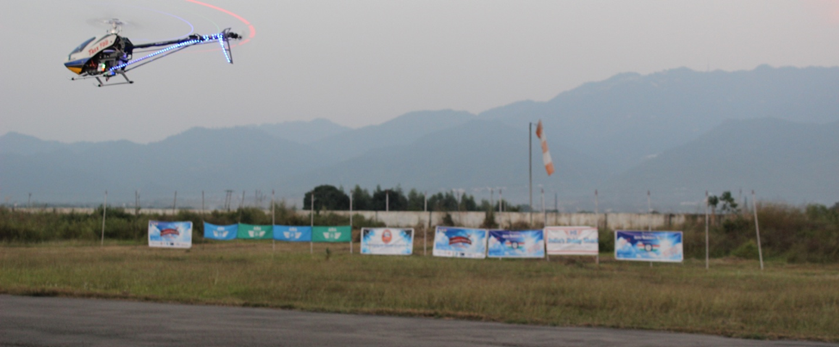

FREQUENCY CONTROL

11. Use of radio frequencies other than 2.4 GHz is not recommended, however, the following points are to be adhered to :-

(a) For all spot frequencies (other than 2.4 GHz),all transmitters may be impounded to protect accidental usage.

(b) While all the efforts will be made by the administrators to maintain vigilance over clash of the frequencies, however, this is without commitment by the organizers. The risk and responsibility shall continue to be that of the flyer / user.

(c) Any RC activity will be strictly restricted from designated areas only. No flying or any other RC activities will be permitted, in areas other than specified, including car parking, public areas and pits.

SAFETY

12. R/C flying planes / helicopters are high speed flying machines and needs to be treated with respect, both, in terms of responsibility and self-discipline, the following points must be kept in mind by all present at the time of competition:-

(a) A chart of do’s and don’ts will be displayed at the event site which, we recommend that all flyers / visitors should abide by in all earnestness.

(h)Particular care should be exercised in respect of young children, since their curiosity may be cause of unwanted accidents. All guardians of such children are strongly advised to ensure that their dependents maintain a respectable distance from these powerful machines, especially when in action.

ACCOMODATION& TRANSPORTATION

13. The accommodation and transportation (from place of stay in Amreli and Amreli airport) for all visitors is being worked out and will be finalized at the earliest, an effort is being made to make the accommodation and transportation available at the subsidies rates through ACI and Gujarat Govt for participants in the event. Bookings have to be made through directly by the guest. Further information will be made available at the earliest.

BANK ACCOUNT DETAILS

14. To send the payments by RTGS / NEFT towards sponsor & advertising the bank details are below:-
(a) A/c Name -Aero Modelers Association NGO

(b) Bank & Branch - Axis Ban, Mansarover Garden New Delhi 110016
(c) A/c No - 915010051480561
(d) RTGS / ISFC Code - UTIB0001101;
15. Note - Kindly mail the amount and UTR number to treasurer@amai.in order for us to confirm the receipt of the payment.

ROUTE INFORMATION

Distances from Amreli Airport < 1Km Travel time <1.5 min
BY CAR TO Amreli Airport
From | To The Amreli Airstrip:
 | Approx Distance | Time Approx
Ahamdabad Railway Station | 250 km apx | 6.25 Hrs
Ahamdabad Airport | 260 km apx | 6.5 Hrs
Rajkoi Railway Station | 115 km Apx | 2.5 Hrs
Rajkot Airport | 120 kms apx | 2.5 Hrs

TRANSPORTATION OF MODELS

16. AMAI, is working to provide collective transport facility by trucks/ vans from given locations in Delhi City, at specific schedules to the event venue. The facility will be provided on charge basis at cost. Intimation of the packages, with approximate dimensions and gross weight should be furnished on or before the 14 Feb 2016. Such transportation will be at the risk of the owner, and the AMAI shall not be responsible for any loss or damage arising there from.

17. Those participants, desirous of seeking assistance for transportation of their models from North Indian cities / locations, to the Amreli airport may kindly contact Mr. Subir Agarwal
(Mobile: +91 9560604442) for assistance. He is the owner Om Logistics.

OUR OFFICIAL LOGISTICS PARTNER

CONTACTS
President AMAI  Mr. Onkar Dutt Sharma  Mobile: +91 9873430004  Email: president@amai.in | Boarding and Lodging  Mr.Laxman Suthar  Mobile: +91 9868284131  Email: treasurer@amai.in
Technical  Lt Col A M Sharma  Mobile: +91 7691916222  Email: amsharma22@gmail,com | Transportation  Mr. Subir Agarwal  Mobile: +91 9560604442  http://www.omlogistics.co.in/contact_us.php

CONCLUSION
18. We welcome all R/C enthusiasts, their families and friends to visit / participate in this great eventbeing organized by and for RC Aeromodelers.We are sure you will have a memorable time. Should you have any further questions, please do not hesitate to contact us at any of the above given references.
19. NB: All information provided, is in good faith & subject to change / updated without prior notice.

